**CS5228 Project Report**

# Group 17 - Workload Distribution

**Chan Jun Wei** (e0374282) : Model Training, Model Tuning, Feature Extraction, Feature Selection

**Chua Chin Siang** (e0403439): Data Preprocessing, Feature Extraction, Model Training

**Tey Shi Wei** (e0403430) : Data Exploration, Data Preprocessing, Model Training

**Wang Zihao** (e0404053) **: MIA**

# Key Words

Column: The column of the given data loaded from .npy.

Feature: Characteristics of the data.

# Data Exploration

P1: Trend vs Time – Each column is investigated, and each column has different features that could contribute to the predictions. For example, column 17 data has high variations and column 11 is sensitive to time length.

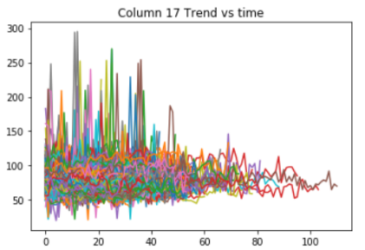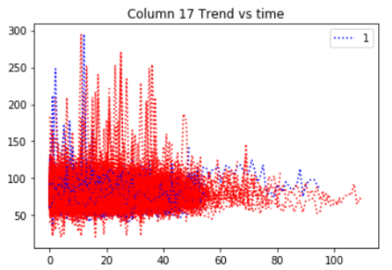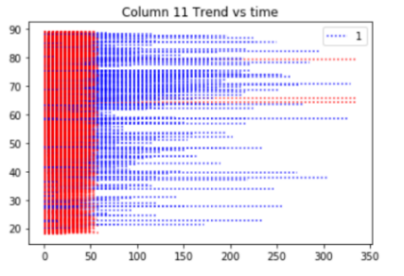

P2: Correlation between columns which is not all NaN and expected label – We found out that when some columns have value which is not NaN, the expected label tends to be 1. In other words, after replacing NaN with a number, data standard deviation will correlate with the label.

|  |  |  |  |
| --- | --- | --- | --- |
| Column | Label 0 | Label 1 | Difference |
| 5 | 30.78% | 63.54% | -32.76% |
| 13 | 46.68% | 77.08% | -30.40% |
| 18 | 50.74% | 78.18% | -27.44% |
| 22 | 48.72% | 77.04% | -28.32% |

# Data Preprocessing

NaN Handling – We set all the NaN to the average value for the column across all the training data. We tried setting all the NaN to 0 but it yields worse result.

# Features Extraction

[TSFresh](https://github.com/blue-yonder/tsfresh) library is used to extract features of time series data. Given a multivariable time series, TSFresh will return many time series characteristics. Based on P1, each column has many different features that contribute to the predictions, TSFresh enables us to consider more characteristics of the time series data. TSFresh considers characteristic including standard deviation, variance, mean, count above mean, which have also considered P2.

We used [extract_features](https://tsfresh.readthedocs.io/en/latest/api/tsfresh.feature_extraction.html#tsfresh.feature_extraction.extraction.extract_features) to get the features and used [select_features](https://tsfresh.readthedocs.io/en/latest/api/tsfresh.feature_selection.html#tsfresh.feature_selection.selection.select_features) to remove irrelevant features. The output results are stored as parquet(.gzip) files for model training later.

# Features Selection

## **Column Selection**

We believe that if an irrelevant column is removed, the model will have better performance. As trying all combination of the columns would cost very long time (2^40 combinations), we employ random search technique with a fixed validation set. However, most result is inconsistent because most of the combinations that score well in the validation set, score worse in Kaggle Public Score.

Nevertheless, removing column 18 consistently give a good result, thus it is chosen in the final submission.

## **Feature Selection Technique**

The features extracted by TSFresh might be irrelevant for the data. Therefore, feature selection techniques are employed to increase the model AUC. Several feature selection techniques were tried including Sklearn Variance Threshold, Sklearn SelectFromModel and some feature selection techniques from Skfeature. SelectFromModel using ExtraTreesClassifier was found to have good performances, thus it is chosen to select individual features in most of the submissions.

We tried running feature selection on individual feature as well as running feature selection on combined data. They are shown in result table.

# Model Training

LightGBM, XgBoost, Tensorflow Neural Network, Sklearn Gradient Boosting are tested. LightGBM yields the best result.

# Model Tuning

Sklearn Random Search CV and [Hyperopt](https://github.com/hyperopt/hyperopt) are experimented. Hyperopt is chosen due to its speed performance. The best parameters found by Hyperopt is {'boosting_type': 'dart', 'metric': 'auc', 'colsample_bytree': 0.7912493015275733, 'learning_rate': 0.1825037992404684, 'min_child_samples': 95, 'num_leaves': 48, 'reg_alpha': 0.5753421176471192, 'reg_lambda': 0.6231841891673146, 'subsample_for_bin': 20000}.

Table 1 Exploration Result Table, validation AUC score is not recorded.

|  |  |  |  |  |  |  |  |
| --- | --- | --- | --- | --- | --- | --- | --- |
| **Column** | **Fill NaN** | **Preprocessing** | **Feature Selection** | **Tuning** | **Model** | **Public Score** | **Private Score** |
| **All but 18** | **Average** | **TSFresh** | **Extra Tree Classifier** | **Hyperopt** | **LightGBM** | **0.96169** | **0.94081** |
| All but 18, 27 | Average | TSFresh | Extra Tree Classifier | None | LightGBM | 0.95695 | 0.9365 |
| All but 27 | Average | TSFresh | Extra Tree Classifier Select for Each Feature | Hyperopt | LightGBM | 0.95909 | 0.93639 |
| All but 18 | Average | TSFresh | Extra Tree Classifier | None | LightGBM | 0.96069 | 0.93373 |
| All but 27 | Average | TSFresh | Extra Tree Classifier Select for Each Feature | None | LightGBM | 0.96063 | 0.93336 |
| All but 18 | Average | TSFresh | Extra Tree Classifier | None | XGBoost | 0.95403 | 0.93057 |
| All but 18 | Average | TSFresh | Extra Tree Classifier | None | Gradient Boosting | 0.95056 | 0.92814 |
| All but 27 | Average | TSFresh | Extra Tree Classifier | None | LightGBM | 0.95609 | 0.92755 |
| All but 18 | Average | TSFresh | None | None | Gradient Boosting | 0.94368 | 0.9187 |
| All | Average | TSFresh | None | None | Gradient Boosting | 0.93715 | 0.91264 |
| All but 2 and 18 | Average | TSFresh | None | None | Gradient Boosting | 0.93338 | 0.90609 |
| 5, 22 | Average | TSFresh | None | None | Gradient Boosting | 0.91056 | 0.87796 |
| 18, 22 | Average | TSFresh | None | None | Gradient Boosting | 0.91187 | 0.87456 |
| 22 | Average | TSFresh | None | None | Gradient Boosting | 0.91283 | 0.87368 |
| 22 | Average | TSFresh | None | None | XGBoost | 0.90624 | 0.86369 |
| 18 | Average | TSFresh | None | None | Gradient Boosting | 0.90419 | 0.86143 |
| 5, 13 | Average | TSFresh | None | None | Gradient Boosting | 0.90916 | 0.86097 |
| 5 | 0 | TSFresh | None | None | Gradient Boosting | 0.88856 | 0.85067 |
| 5, 33 | Average | TSFresh | None | None | Gradient Boosting | 0.89429 | 0.84817 |
| 5 | Average | TSFresh | None | None | Gradient Boosting | 0.89372 | 0.84773 |
| 13 | Average | TSFresh | None | None | Gradient Boosting | 0.85919 | 0.80678 |
| 33 | 0 | TSFresh | None | None | Gradient Boosting | 0.84482 | 0.78877 |
| 26 | Average | TSFresh | None | None | Gradient Boosting | 0.8261 | 0.78346 |
| 0 | Average | TSFresh | None | None | Gradient Boosting | 0.82475 | 0.78263 |
| 2 | 0 | TSFresh | None | None | Gradient Boosting | 0.82657 | 0.77792 |
| 35 | Average | TSFresh | None | None | Gradient Boosting | 0.8246 | 0.77493 |
| 11 | 0 | TSFresh | None | None | Gradient Boosting | 0.82215 | 0.7724 |
| All | Average | TSFresh | FCBF | None | Gradient Boosting | 0.77254 | 0.25281 |
| 2,3,6,8,11,12,13,15,17,18,22,24,26,29,31,33,35,37,39 | 0 | None | None | None | Tensorflow Neural Network | 0.90039 | 0.85684 |
| 22 | 0 | None | None | None | Tensorflow Neural Network | 0.89307 | 0.83614 |
| 22 | 0 | None | None | None | Tensorflow Neural Network | 0.8971 | 0.86794 |
| 2 | 0 | None | None | None | Tensorflow Neural Network | 0.84987 | 0.80797 |
| 22 | Average | TSFresh | None | Random Search Optimization | LightGBM | 0.8483 | 0.8206 |